Remote office is the replacement for Single Number Reach. A username and password will be provided to you. Please follow the instructions below to access the Remote Office portal.

- From any web browser, navigate to https://evolveip.my-cloud-manager.com/PersonalPortal/login.jsp
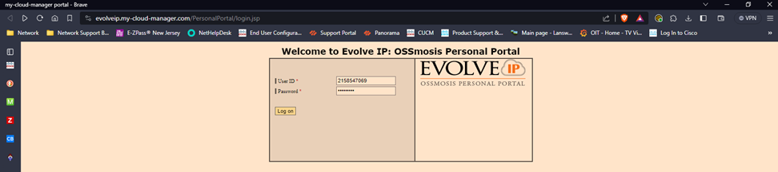
- After successfully logging in with your username and password (provided to you) you will be brought to the Welcome screen, shown below. From this screen find and click on Advanced Features.
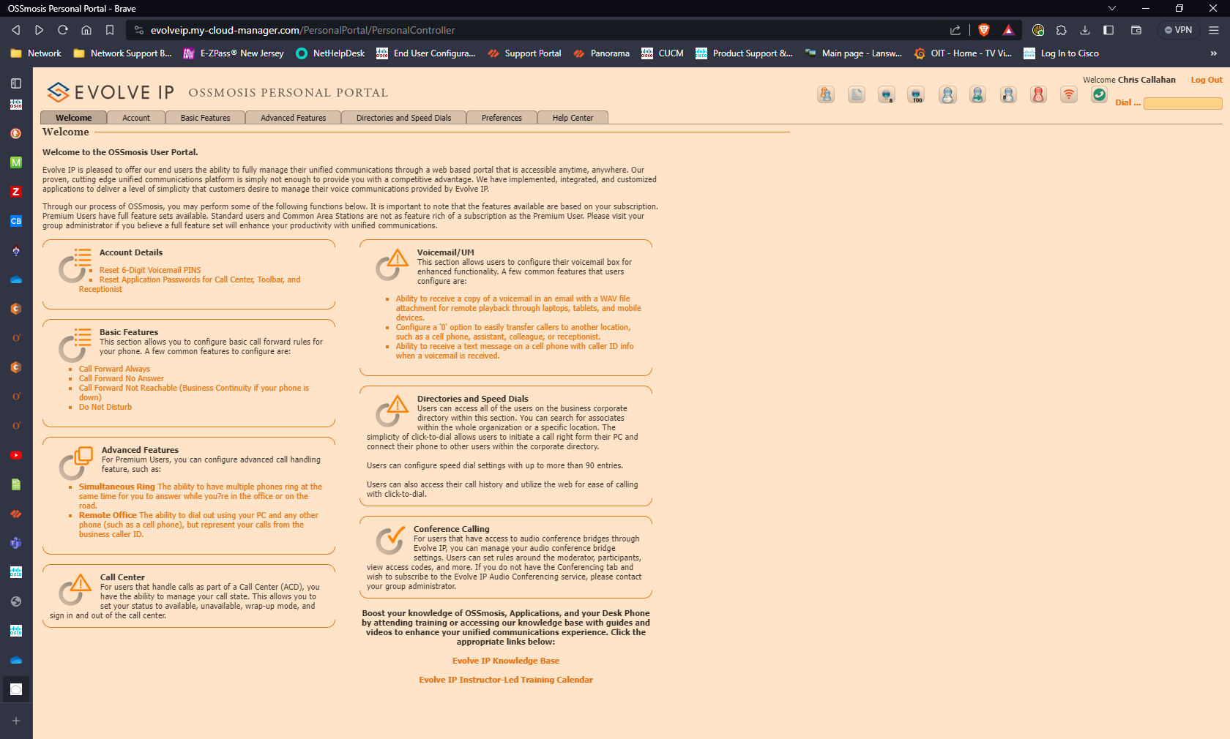

- Click on “Remote Office” tab and accept the pop-up message by clicking on OK.
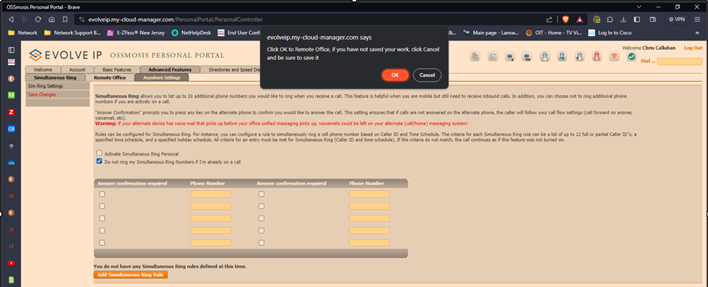
- Check the box to “Enable Remote Office” then type in your cell number in the Phone Number Field.
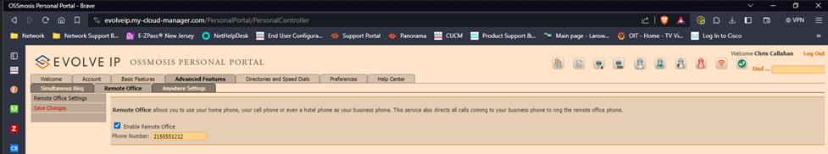
- Then click on Save Changes to the left of the check box.
  - To disable this feature, simply log back on and uncheck the “enable remote office” option and save your changes.

For assistance, please contact the Help Desk at 215-854-7067 or by email address help@chs-adphila.org.

